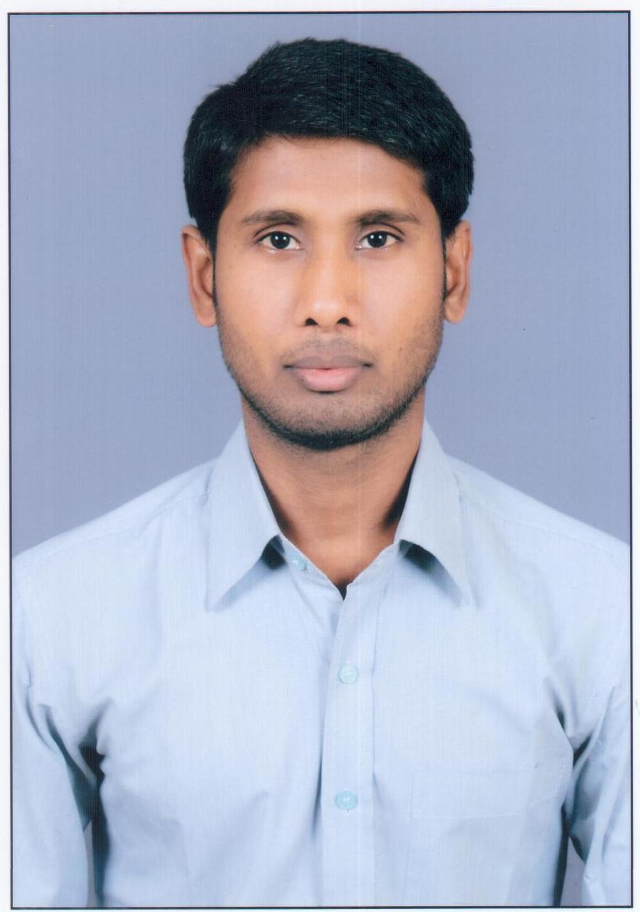
JECRC
Affix and Attest
passport
size photograph
JAIPUR

INDIVIDUAL TECHNICIAN DATA SHEET
Name of the Technical staff member | : | Anil Kumar Prajapati
Present Designation | : | Lab Instructor
Email Id: :anil.prajapati@ymail.com
Contact Details :9928446208

I. Particulars of Educational Qualification: (only completed)

Category | Name of the Degree | Specialization | Year of Passing | Name of the College | Name of the University
ITI | ITI | computer | 2009 | Md. ITI | BTER
Diploma | Diploma | Mechanical | 2014 | Ch. Parmaram godara polytechnic college, hanumangarh | BTER

II. Academic Experience : 2 Year

III. Industrial Experience :

